Name of Facility
Location

Title: COVID-19 Abbott BinaxNOW Procedure #:
If possible, perform this test in a biological safety hood. Use standard precautions wearing gloves, gown, mask, face shield or goggles when performing this test.
Purpose: | The BinaxNOW COVID-19 Ag Card is a rapid lateral flow immunoassay for the qualitative detection and diagnosis of SARS-CoV-2 directly from nasal swabs, without viral transport media. The immunoassay is intended for qualitative detection of antigen in direct nasal swabs from individuals suspected within the first seven days of symptom onset. Negative results from patients with symptom onset beyond seven days, should be treated as presumptive and confirmation with a molecular assay, if necessary, for patient management, may be performed Negative results do not rule out SARS-CoV-2 infection and should not be used as the sole basis for treatment or patient management decisions, including infection control decisions. Negative results should be considered in the context of patient’s recent exposures, history and the presence of clinical signs and symptoms consistent with COVID-19.  The BinaxNOW Covid-19 Ag Card is an immunochromatographic membrane assay that uses highly sensitive antibodies to detect SARS-CoV-2 nucleocapsid protein from nasal swab specimens. SARS-CoV-2 specific antibodies and a control antibody are immobilized onto a membrane support as two distinct lines and combined with other reagents/pads to construct a test strip. This test strip and a well to hold the swab specimen are mounted on opposuite sides of a cardboard, book-shaped hinged test card.  To perform the test, a nasal swab specimen is collected from the patient, 6 drops of extraction reagent from a dropper bottle are added to the top hole of the swab well. The patient sample is inserted into the test card through the bottom hole of the swab well, and firmly pushed upwards until the swab tip is visible through the top hole. The swab is rotated 3 times clockwise and the card is closed, bringing the extracted sample into contact with the test strip. Test results are interpreted visually at 15 minutes based on the presence of absence of visually detectable pink/purple colored lines. Results should not be read after 30 minutes.  CLIA COMPLEXITY: Waived
Reagents and Equipment Required: | Store kit at 2-30 degrees C. The kit is stable until the expiration date marked on the outer packaging containers. Ensure all test components are at room temperature before use.  Test Cards (40): A cardboard, book-shaped hinged test card containing the test strip  Extraction Reagent (1): Bottle containing 10 mL of extraction reagent  Nasal Swabs (40): Sterile swabs for use with BinaxNOW COVID-19 Ag Card test  Positive Control Swab (1): Non-infectious recombinant SARS-CoV-2 nucleocapsid antigen dried onto a swab  Negative Control Swab: The use of a sterile patient swab ensures appropriate negative results are obtained.  Product Insert (1)  Procedure Card (1)  Materials Required but not Provided  Clock, timer or stopwatch  Materials Available as an Optional Accessory  Swab Transport Tube Accessory Pack
Precautions | - For in vitro diagnostic use.  - This test has not been FDA cleared or approved; this test has been authorized by FDA under an EUA for use by laboratories certified under the Clinical Laboratory Improvement Amendments of 1988 (CLIA), 42 U.S.C.§263a, to perform moderate, high or waived complexity tests and at the Point of Care (POC), i.e. in patient care settings operating under a CLIA certificate of Waiver, Certificate of Compliance, or Certificate of Accreditation.  - Federal Law restricts this device to sale by or on the order of a licensed practitioner (US only).  - This test has been authorized only for the detection of SARS-CoV-2 antigen, not for any other viruses or pathogens.  - This test is only authorized for the duration of the declaration that circumstances exist justifying the authorization of emergency use of in vitro diagnostic tests for detection and/or diagnosis of COVID-19 under Section 564(b)(1) of the Act, 21 U.S.C. §36obbb-3(b)(1), unless the authorization is terminated or revoked sooner.  - Laboratories within the United States and its territories are required to report all positive results to the appropriate public health laboratories.  - Treat all specimens as potentially infectious. Follow universal precautions when handling samples, this kit and its contents.  - Proper sample collection, storage and transport are essential for correct results.  - Leave test card sealed in its foil pouch until just before use. Do not use if pouch is damaged or open.  - D not use kit past its expiration date.  - Do not mix components from different kit lots.  - Do not reuse the used test card.  - Inadequate or inappropriate sample collection, storage, and transport may yield false test results.  - Do not store specimens in viral transport media for specimen storage.  - All components of this kit should be discarded as Biohazard waste according to Federal, Ste and local regulatory requirements.  - Solutions used to make the positive control swab are non-infectious. However, patient samples, controls, and test cards should be handled as though they could transmit disease. Observe established precautions against microbial hazards during use and disposal.  - Wear appropriate personal protection equipment and gloves when running each test and handling patient specimens. Change gloves between handling of specimens suspected of COVID-19.  - INVALID RESULTS can occur when an insufficient volume of extraction reagent is added to the test card. To ensure delivery of adequate volume, hold vial vertically, ½ inch above the swab well, and add drops slowly.  - False Negative results can occur if the sample swab is not rotated (twirled) prior to closing the card.  - Swabs in the kit are approved for use with BinaxNOW CVOVID-19 Ag Card. Do not use other swabs.  - The extraction Reagent packaged in this kit contains saline, detergents and preservatives that will inactivate cells and virus particles. Samples eluted in this solution are not suitable for culture.  - Do not store the swab after specimen collection in the original paper packaging, if storage is needed use a plastic tube with cap.
Specimen: | Test specimens immediately after collection for optimal test performance. Inadequate specimen collection or improper sample handling/storage/transport may yield erroneous results. Refer to the CDC Interim Guidelines for Collecting Handling, and Testing Clinical Specimens from Persons for Coronavirus Disease 2019 (COVID-19) https://www.cdc.gov/coronavirus/2019-nCoV/lab/guidelines-clinical-specimens.html
Specimen Collection and Handling: | Nasal Swab  Only the swab provided in the kit is to be used for nasal swab collection.  To collect a nasal swab sample, carefully insert the swab into the nostril exhibiting the most visible drainage, or the nostril that is most congested if drainage is not visible. Using gentle rotation, push the swab until resistance is met at the level of the turbinates (less than one inch into the nostril). Rotate the swab 5 times or more against the nasal wall then slowly remove from the nostril. Using the same swab, repeat sample collection in the other nostril.
Specimen Transport and Storage: | No not return the nasal swab to the original paper packaging.  For best performance, direct nasal swabs should be tested as soon as possible after collection. If immediate testing is not possible, and to maintain best performance and avoid possible contamination, it is highly recommended the nasal swab is placed in a clean, unused plastic tube labeled with patient information, preserving sample integrity, and capped tightly at room temperature (15-30 degrees C) for up to (1) hour prior to testing. Ensure the swab fits securely within the tube and the cap is tightly closed. If greater than 1 hour delay occurs, dispose of sample. A new sample must be collected for testing.
Procedure: | Open the test card just prior to use, lay it flat, and perform assay as follows. The test card must be flat when performing testing, do not perform testing with the test card in any other position.  - Hold Extraction Reagent bottle vertically. Hovering ½ inch above the TOP HOLE, slowly add 6 DROPS to the TOP HOLE of the swab well. DO NOT touch the card with the dropper tip while dispensing.  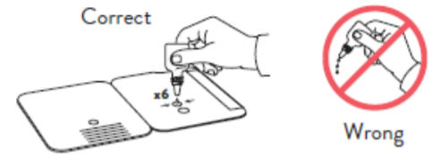  - Insert sample into BOTTOM HOLE and firmly push upwards so that the swab tip is visible in the TOP HOLE.  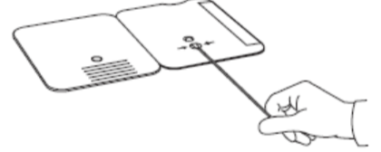  - Rotate (twirl) swab shaft 3 times CLOCKWISE (to the right). Do not remove swab.  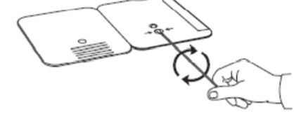  Note: Fales negative results can occur if the sample swab is not rotated (twirled) prior to closing the card.  - Peel off adhesive liner from the right edge of the test card. Close and securely seal the card. Read result in the window 15 minutes after closing the card. In order to ensure proper test performance, it is important to read the result promptly at 15 minutes, and not before. Results should not be read after 30 minutes.  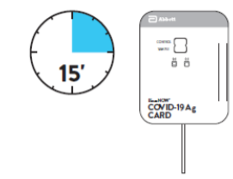  Note: When reading test results, tilt the card to reduce glare on the result window if necessary. Individuals with color-impaired vision may not be able to adequately interpret test results.
Quality Control | External positive and negative controls must be performed to ensure that test reagents are working and that the test is correctly performed. External controls must be performed with each new shipment received and once for each untrained operator. If the correct control results are not obtained, do not perform patient tests or report patient results.  Procedure for BinaxNOW Swab Controls  Open the test card just prior to use, lay it flat and perform assay as follows.  - Hold Extraction Reagent bottle vertically hovering ½ inch above the TOP HOLE, slowly add 8 DROPS to the TOP HOLE of the sab well. DO NOT touch the card with the dropper tip while dispensing.  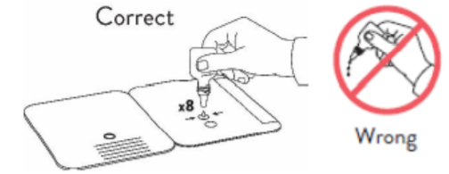  - Follow Steps 2 – 4 of the Test Procedure for Patient Specimens.
Result Interpretation | Note: In an untested BinaxNOW COVID-19 Ag Card there will be a blue line present at the Control Line position. In a valid, tested device, the blue line washes away and a pink/purple line appears, confirming that the sample has flowed through the test strip and the reagents are working. If the blue line is not present at the Control Line position prior to running the test, do not use and discard the test card.  Negative  A negative specimen will give a single pink/purple colored Control Line in the top half of the window, indicating a negative result. This Control Line means that the detection part of the test was done correctly, but no COVID-19 antigen was detected.  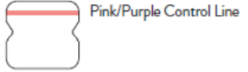  Positive  A positive specimen will give two pink/purple colored lines. This means that COVID-19 antigen was detected. Specimens with low levels of antigen may give a faint sample line. Any visible pink/purple colored line is positive.  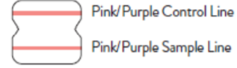  Invalid  If no lines are seen, if just the Sample Line is seen, or the Blue Control Line remains blue, the assay is invalid. Invalid tests should be repeated.  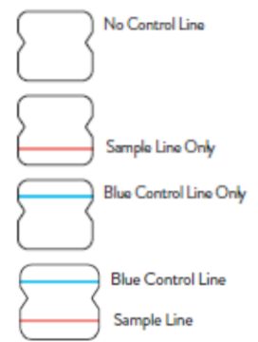
Reporting of Results: | Call all positive results immediately to the ordering physician and report all results to the Iowa Department of Public Health.
Limit of Detection (LOD) | See Product Insert Sheet for Limit of Detection, Cross Reactivity and Microbial Interferecne
Performance Characteristics: | See Product Insert Sheet
Limitations: | - This test detects both viable (live) and non-viable, SARS-CoV, and SARS-CoV-2. Test performance depends on the amount of virus (antigen) in the sample and may or may not correlate with viral culture results performed on the same sample.  - A negative test result may occur if the level of antigen in a sample is below the detection limit of the test.  - The performance of the BinaxNOW COVID-19 Ag Card was evaluated using the procedures provided in this product insert only. Modification so these procedures may alter the performance of the test.  - False negative results may occur if a specimen is improperly collected, transported, or handled.  - False results may occur if specimens are test past 1 hour of collection. Specimens should be tested as quickly as possible after specimen collection.  - False negative results may occur if inadequate extraction buffer is used (e.g., <6 drops).  - False negative results may occur if specimen swabs are not twirled within the test card.  - False negative results may occur if swabs are stored in their paper sheath after specimen collection.  - Positive test results do not rule out co-infections with other pathogens.  - Positive test results do not differentiate between SARS-CoV and SARS-CoV-2.  - Negative test results are not intended to rule in other non-SARS viral or bacterial infections.  - The presence of mupirocin may interfere with the BinaxNOW COVID-19 Ag test and may cause false negative results.  - Negative results, from patients with symptom onset beyond seven days, should be treated as presumptive and confirmation with a molecular assay, if necessary, for patient management, may be performed.  - If the differentiation of specific SARS viruses and strains is needed, additional testing, in consultation with state or local public health departments, is required.
References: | Package Insert, COVID-19, Abbott Diagnostics Scarborough, Inc., Scarborough, ME, 1 2020/08

