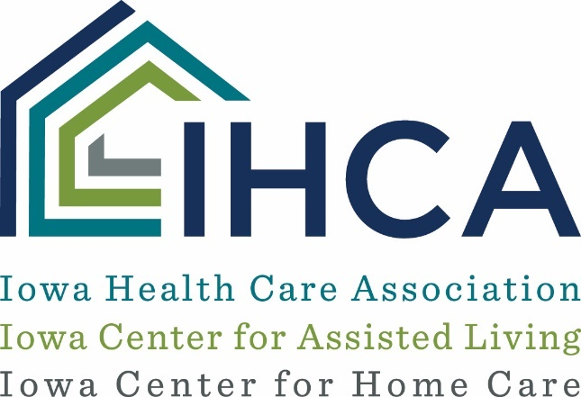

COVID-19 Screening Consent Form and Waiver – Nursing Facility
This consent provides ____________________________ (“Facility”) with your permission to perform a COVID-19 screening procedure based on the Facility’s need to maintain a safe environment for residents, employees, visitors, vendors, and other essential persons with whom you may come into contact. By signing below, you are indicating that you consent to this procedure for the detection of COVID-19.

The test being administered involves a nasal swab that will be tested to indicate the potential presence of COVID-19. If you decline the test, you will not be allowed to enter the Facility, as consenting to this test is a condition of your continued employment. Test results will be provided to the Facility and will be maintained in your employee health file.

This test has been approved by the FDA, however, this test alone may not be sufficient to detect or rule out the possibility that you have been exposed to or are infected with COVID-19. You should carefully monitor your own symptoms, and, notwithstanding the results of any testing, you must stay home and consult with your physician if you experience symptoms of COVID-19. You should refer to the Facility’s policies regarding reporting and leave for additional details about these matters.

You have the right to discuss the proposed testing with your physician to learn about the purpose, potential risks and benefits of any testing. If you test positive or have symptoms, you should contact a physician or other medical professional for advice. The cost of any medical care is your responsibility. Because of the ongoing public-health crisis, it may be necessary for the Facility to share the results of your test with public health authorities or with others in limited instances.

By signing below, you consent to the disclosure of such information as requested, recommended or required by federal, state, and local public health authorities. By signing below, you agree to release and waive any claim arising from your selection to receive this screening, that may arise against the Facility and its designated medical providers and staff members. Additionally, you agree to release and waive any claim that might arise against the Facility and its designated medical providers and staff members for any risks, side effects, or complications resulting from the testing, including but not limited to any claim of negligence.

_____________________________ ______________
Printed Name Date

_____________________________ ______________
Signature Date

If employee is a minor signature of parent/guardian

____________________________ ______________
Signature Date

___________________________ ______________
Printed Name Date

