Patient Contact Garment
Items # PCG1-2NS-60, PCG1-2NS-55

These garments meet the certification requirements of AAMI Level 2 protection.

Intended Use

Non-surgical full-coverage Patient Contact Garment (with easy access side ties) intended to protect health care patients and personnel from the transfer of microorganisms, body fluids (Fluid repellent) and particulate material. Single-use and disposable. Latex Free.

Material Composition

Sontara
56% Wood pulp – 44% Polyester

Typical Material Properties
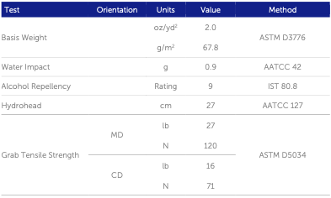

Additional Information

PCG1-2NS-60 Patient Contact Garment, Style 1, Level 2 Non-sterile, 6.0 feet size
PCG1-2NS-55 Patient Contact Garment, Style 1, Level 2 Non-sterile, 5.5 feet size

(Style 1 is a protection garment with side ties for easy access)

Individually bagged, Packaged 25 per box, 40 boxes per pallet, 1000 garments per pallet

500 lbs. per pallet

IMAGES

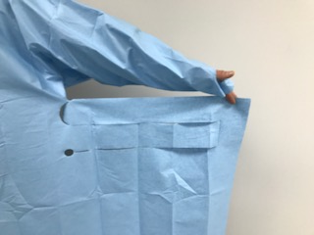
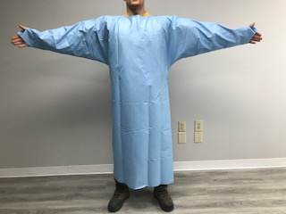

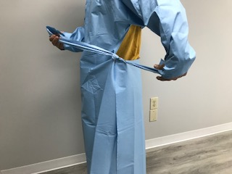
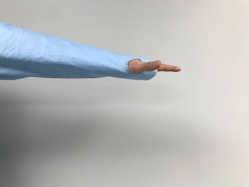

Front Side tie System

Side tie for better flexibility Thumb Holes for better coverage

