Patient Contact Garment
Items # PCG4-2NS-60, PCG4-2NS-55

These garments meet the certification requirements of AAMI Level 2 protection.

Intended Use

Non-surgical full-coverage Patient Contact Garment (with belt) intended to protect health care patients and personnel from the transfer of microorganisms, body fluids (Fluid repellent) and particulate material. Single-use and disposable. Latex Free.

Material Composition

Sontara
56% Wood pulp – 44% Polyester
Blue

Typical Material Properties
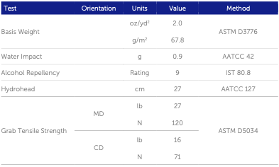

Additional Information

PCG4-2NS-60 Patient Contact Garment, Style 4, Level 2 Non-sterile, 6.0 feet size
PCG4-2NS-55 Patient Contact Garment, Style 4, Level 2 Non-sterile, 5.5 feet size

(Style 4 is a full protection garment covering the sides of the torso)

Individually bagged, Packaged 25 per box, 40 boxes per pallet, 1000 garments per pallet

500 lbs. per pallet

Images

