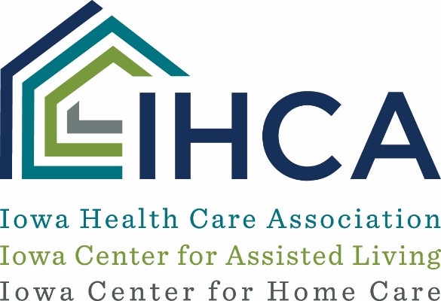
Patient Screening and Care Protocols for NFs and ALs - 3/20/2020
Highlights from a provider CDC COVID-19 presentation on 3/17/2020 are presented below. A recording of the entire webinar may be accessed on the CDC website. IHCA has summarized critical information for long term care and assisted living providers below:
General Information about COVID-19:
- Incubation period for COVID-19 is up to 14 days but usually symptoms appear on days 2-4.
- Patients are most often hospitalized on day 7 of the illness.
- 20-30% of hospitalized patients will require mechanical ventilation support
- The elderly often do not show remarkable symptoms early but may have confusion and malaise.
- Mild illness moves quickly into a serious illness.
- COVID-19 is much more easily transmitted than the flu and creates more dire consequences for our patients.
- You should assume that COVID-19 is already circulating in your community and act accordingly.
- Health care workers and visitors to buildings are the greatest risk for spread of the illness. Follow CDC guidelines for the return of health care workers who become ill to your organization.
Things to implement right now:
- The CMS and DIA restrictions regarding visitors and essential health care workers should be followed consistently.
- All patients should be monitored at least one time daily for temperature, pulse, respirations and blood oxygen level determined. Respond to variations in vital signs appropriately. An elevated pulse rate might be an early sign of a change in condition and an indication to increase daily screening to at least bid. New admissions should warrant bid screening for a while as well.
- Inventory PPE and secure it. Create a plan that will help you conserve PPE when it is needed and educate and practice with staff now on use. CDC guidance for conservative use of PPE is on our COVID-19 website.
- Create a special team that will be taking care of the first suspected COVID-19 you identify.
- Be in contact with your local lab to make sure you have testing swabs available before you need them.
- Given the mortality rate associated with COVID-19 among our patients you should take time before you have a suspected case to review everyone’s advanced directives and/or IPOST documents. Talk with residents and responsible parties about their wishes for advanced medical care if the resident becomes ill. This is important to consider now BEFORE you have cases occur.
What to do when you have a suspected case:
- Follow the reporting requirements listed on our website. Contact the patient’s medical provider. Follow any recommendations for testing.
- Immediately isolate the suspected resident or employee. If an employee have them don a mask and leave the facility and seek medical advice. If a patient shows symptoms of a respiratory illness of any kind, move them to a private room and implement contact and droplet isolation precautions that require gown, mask, gloves and eye protection.
- Follow CDC guidelines for conservative use of all PPE. Gloves and gowns must be changed between care for isolated patients. Masks and eye protection may be used between patients if not contaminated or wet and remaining in good condition,
- Begin bid vital sign assessment of all patients and be vigilant in responding to any others who show potential signs of illness and isolate and report as needed.
- Require off duty workers to self-monitor for symptoms when at home and to stay away from group gatherings if possible.
- Maintain social distancing among all patients and among workers as much as possible.
- Continue to complete meticulous environmental cleaning with approved products in all areas of your facility several times daily.
- Try to limit the number of staff members who are caring for isolated patients if possible.

