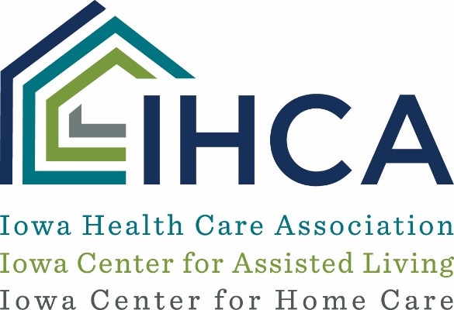
CDC Guidance on When Health Care Personnel Can Return to Work - 3/20/2020
Many IHCA members are asking when a staff person who is staying home because of fever or respiratory symptoms can return to work. CDC posted guidance from March 16, 2020 on criteria for return to work. Use one of the below strategies to determine when health care personnel (HCP) may return to work in health care settings:
- Non-test-based strategy. Exclude from work until:
  - At least 3 days (72 hours) have passed since recovery, defined as resolution of fever without the use of fever-reducing medications and improvement in respiratory symptoms (e.g., cough, shortness of breath); and,
  - At least 7 days have passed since symptoms first appeared
- Test-based strategy, if tests are available. Exclude from work until:
  - Resolution of fever without the use of fever-reducing medications and
  - Improvement in respiratory symptoms (e.g., cough, shortness of breath), and
  - Negative results of an FDA Emergency Use Authorized molecular assay for COVID-19 from at least two consecutive nasopharyngeal swab specimens collected ≥24 hours apart (total of two negative specimens)
If HCP were never tested for COVID-19 but have an alternate diagnosis (e.g., tested positive for influenza), criteria for return to work should be based on that diagnosis.
Please read the entire guidance posted on the CDC page dated March 16, 2020.

